

ROCKING HORSE MONEY

BIOGRAPHY

Rocking Horse Money are a three-piece Country/Americana band rooted in Bluegrass, Old Time and early Rock & Roll music.

Featuring IBMA-nominated fiddle, dobro and steel player Laura Carrivick, alongside singer-songwriter and guitarist Oliver Seymour and upright bassist John Breese, the band combine exceptional musicianship with a distinctive, energetic live sound.

Performing sets of largely original material, Rocking Horse Money draw heavily on the great American traditions of Bluegrass, Country, Honky-Tonk and early Rock & Roll. Their music is authentic, characterful and made for the live stage.

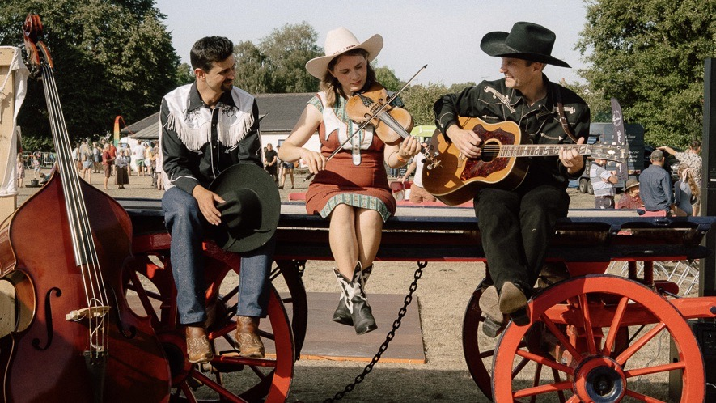
The band’s primary songwriter, Oliver Seymour, has had a lifelong obsession with early rock and roll music. So much so that he is creator and producer of the large scale stage show Rave On, a theatrical celebration of 1950s Rock & Roll. The production tours to more than 80 theatres across the UK every year. The band’s rich knowledge of the Golden Era of Country and Rock & Roll, combined with Laura's searing Bluegrass chops and John’s back-bone bass playing gives Rocking Horse Money a particularly authentic connection to the music they draw from.

LINKS

rockinghorsemoney.wixsite.com/band
facebook.com/rockinghorsemoney
instagram.com/rockinghorsemoney
youtube.com/@RockingHorseMoney
rockinghorsemoney.bandcamp.com/

For further information, please contact Ant Miles at Fancourt Music
+44 7837 881941 | ant.miles@fancourtmusic.com | fancourtmusic.com

